**Google Speech to Text GUI**

By

Joseph Lukan

**Requirements for this documentation:**

* Windows PC (Procedure would be different to Linux, Mac,..)
* Minimum RAM of 1GB
* Minimum Storage Space of 512MB
* Good Internet

**Software Required:**

* XAMPP
* FFMPEG
* GIT
* Any Internet Browser (Chrome, IE, ..)

**PROCEEDURE**

1. Download xampp from <https://www.apachefriends.org/index.html>
2. Install xampp and accept all defaults during the installation
3. Open Xampp Control Panel
4. On the same line with Apache, click the “Config” button then choose “PHP (php.ini)”

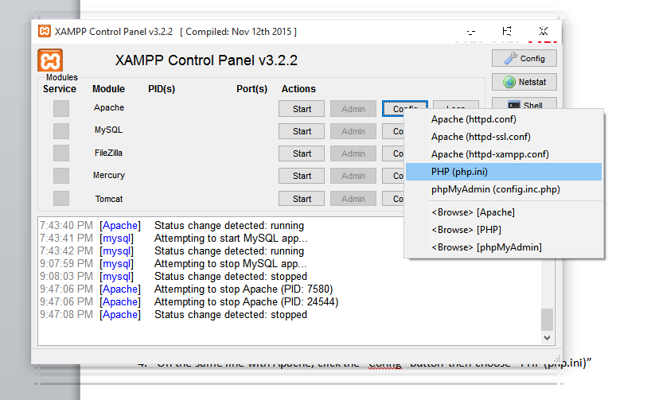

1. In the text editor, find "max_execution_time", set value to 0

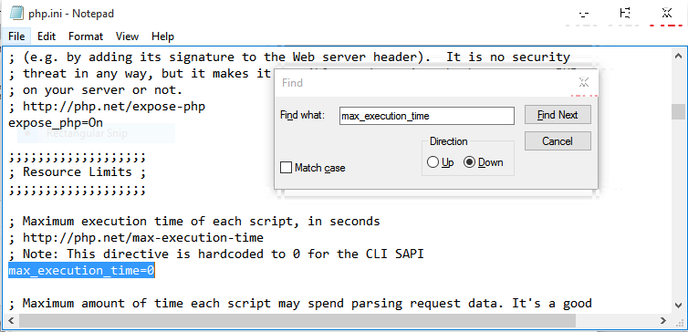

1. Save and close
2. Download git from <https://git-for-windows.github.io/>
3. Install git and accept all default values during installation
4. Press “windows”+R. In the Run window, type “cmd” hit enter.

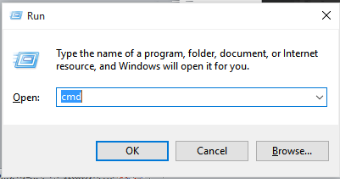

1. In the black screen, type “cd C:\xampp\htdocs” without quotes and hit enter, you should have something similar to this below

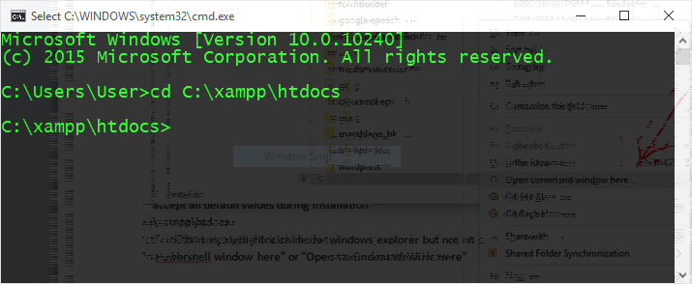

1. Still in the command interface type "git clone <https://github.com/ztobs/Speech-To-Text-GUI.git>" without the quotes and hit enter. When everything is complete you should get something similar to this below

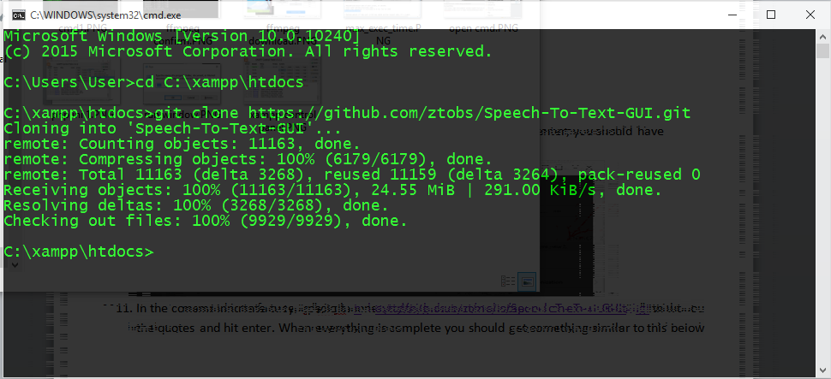

1. Download ffmpeg from <http://ffmpeg.zeranoe.com/builds/>

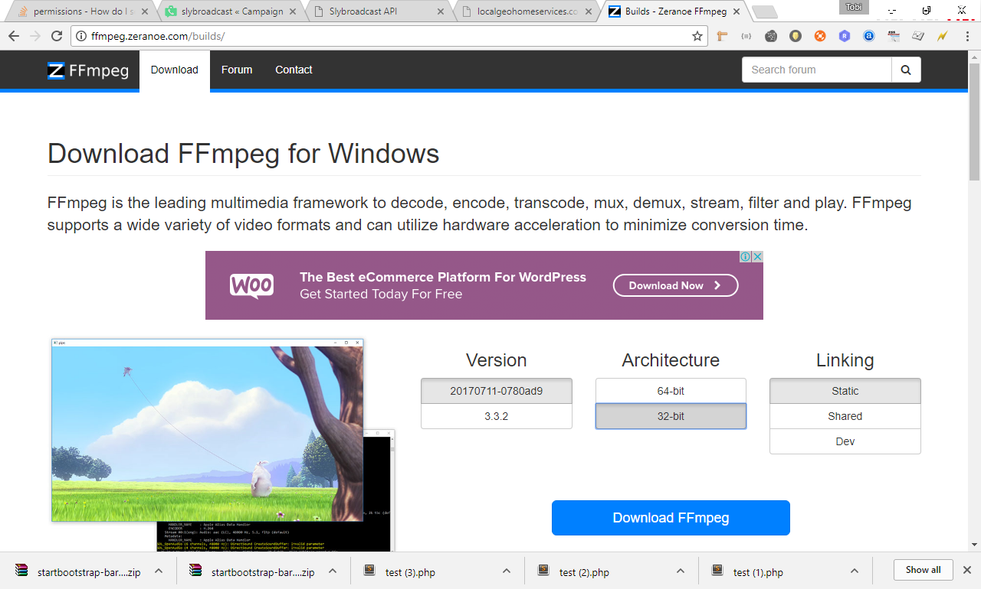

1. Extract ffmpeg to C:/

that is the root of the drive

1. Rename the directory to “ffmpeg”
2. Open a command prompt with administrator's rights.  
   Run the command with the quotes:  
   setx /M PATH "C:\ffmpeg\bin;%PATH%"

Also run this command with the quotes:

setx /M PATH " C:\xampp\php\;%PATH%"

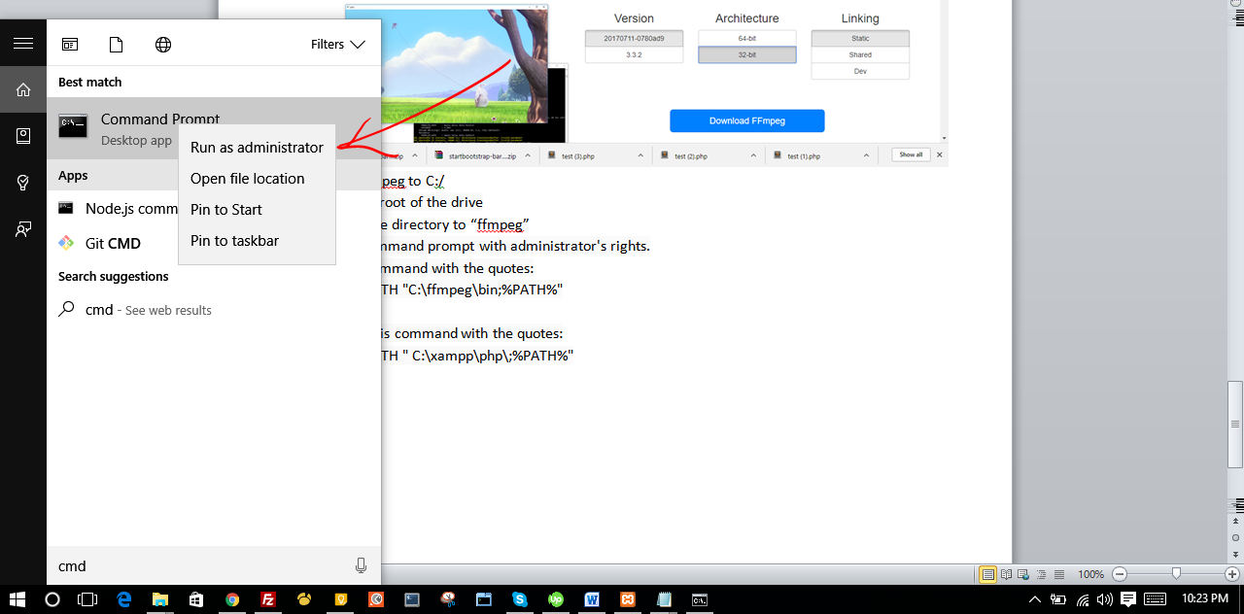

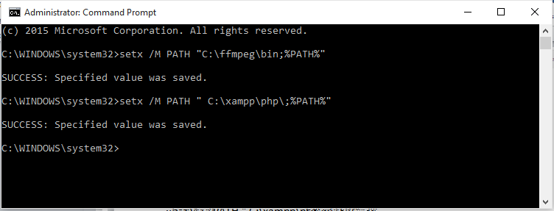

1. Close the command interface and open it again. To confirm you have properly set the paths, type “php -v” and hit enter, also type

“ffmpeg” and hit enter

If you get some info stating the versions for php and ffmpeg, then you did it right.

1. Restart your PC for the paths to properly work
2. Open xampp control panel and start apache, you should see ports 80,443

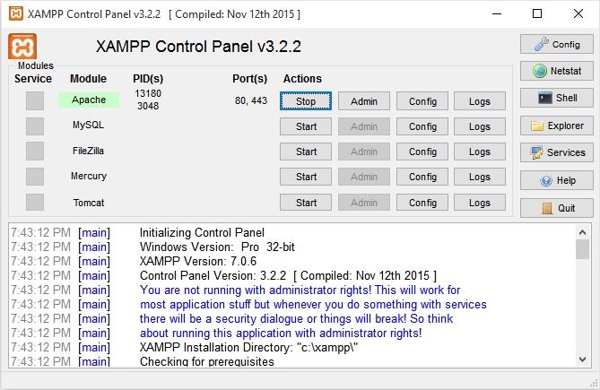

1. Now access the web app in your browser with this url <http://127.0.0.1/Speech-To-Text-GUI>
2. Drop a file, click “Upload” then click “Convert”. Process could take several seconds depending on the size of audio file

**NB:**

Repeat Step 18 each time the PC is restarted